3 Creative Ways to Label a Quilt

(Borrowed from www.suzyquilts.com)
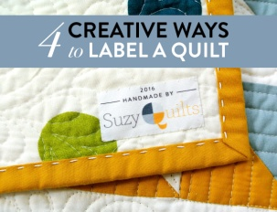

In the words of the 21st century philosopher Beyoncé, “If you liked it then you should have put a label on it.” What? she didn’t say that? Well, I'm pretty sure it was something close to that.
We all know that quilting takes some WORK, and whether you’re giving that finished masterpiece to your niece, selling it on Etsy, or even just keeping the dang quilt cause you made it and you deserve it... that quilt needs its own personal label.
Quilt labels come in all shapes, sizes, materials and styles, so you can experiment and figure out what works for you. If you have any interest in entering your quilt into a gallery or show, one main requirement is a label, so you might as well start labeling all of your quilts! Here are some great, creative ways to label your quilt, so you get credit where credit is due!

Print Your Own on Freezer Paper
I do this every time I send a quilt off to be displayed in a quilt show. Quilt shows typically require a lot more information on a quilt label than you would normally put on a quilt – for example, your address.

Print Your Own Quilt Label Tutorial
- To start, cut a piece of freezer paper and light-colored fabric slightly larger than a standard piece of printer paper (in the US, that's 8 1/2" x 11").
- Place the freezer paper shiny side down on top of the fabric. The freezer paper will stick a bit.
- With an iron on the cotton setting, press the freezer paper onto the fabric until it sticks (this only takes a few seconds.)
- Using your ruler and rotary cutter, trim them both to the exact size of regular printer paper.
- Now, you can feed your fabric-and-freezer-paper sheet into your printer as if it was printing paper! I had to change a setting on my printer so I could feed the "thick paper" into a tray in the back, but other than that, it's easy-peezy!
- After you print, simply peel off the freezer paper and voila! You have your very own quilting label.
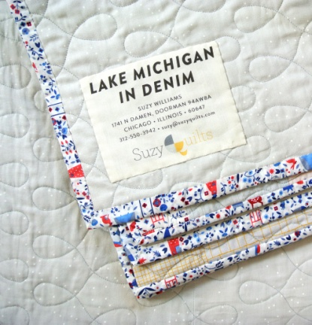

Embroidery
Even though embroidery takes some time, and most people need to practice a bit before getting the hang of it, embroidery is a great way to make hyper-customized labels for quilts that are really beautiful. A friend of mine recently took this embroidery class on Craftsy and is now making some stunningly stitched things!
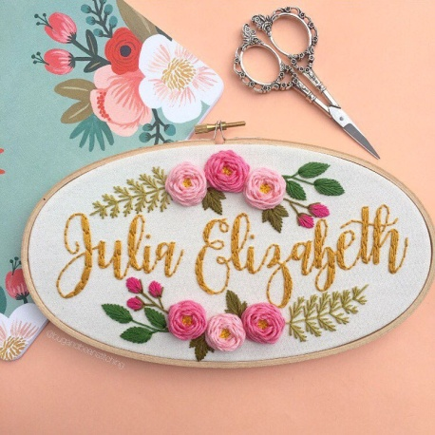
If you loooove the embroidery above, but don't feel up to the task of making it yourself, I bet if you asked nicely, this pretty little shop, Bug & Bean, would embroider a quilt label just for you!

Custom Woven Quilt Label
If you want to get real professional, you can also buy custom quilt labels. There are many independent label sellers online that do a very high-quality job. Custom labels can be great for serious sellers, and make quilts look especially official. They’re also a fun way to make a gift extra-special.
When I ordered this set of labels I was deeply obsessed with my hobby as an amateur quilt historian. I wanted to be sure that 100 years from now my great-grandchildren knew exactly when their awesome ancestor made the heirloom quilt that now hangs front and center in their main foyer. So, in that vein, I printed all of my labels with dates...not realizing that a batch of 100 labels might be a few too many for one year. Ooops!
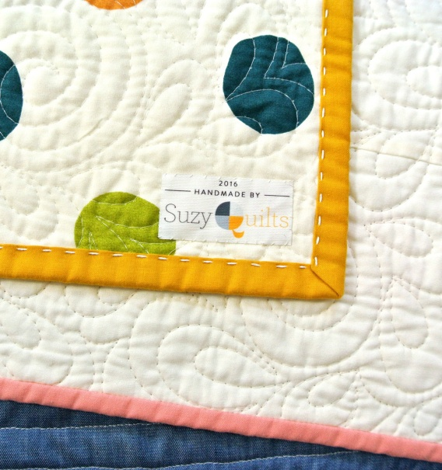

In the infamous words of the candy company, Reese’s, “There’s no wrong way to label a quilt.” Get your name on there, let people know it came from your, talented, crafty hands, you deserve it.

